Table of Contents

1. Version History

2. Introduction

3. Targeted Audience

4. Scope

5. Application Architecture
- Overview
- Components

6. Business Architecture
- Use Case Diagrams
- Use Case Descriptions

7. Detailed Design
- Entity-Relationship Diagram (ERD)
- Database Model

8. Data Architecture
- Authentication and Authorization
- Data Encryption

9. Security Architecture
- Authentication and Authorization
- Data Encryption

10. Deployment Architecture
- Infrastructure
- Deployment Model

11. Testing Model
- JUnit Testing
- Integration Testing

12. References

13. Acronyms/Abbreviations

14. List of Figures

High-Level Design Report for Food Waste Reduction Platform

1. Version History

Version 1.0 by:

- Jacob Elliott #40732505
- Navjot Kaur #041085639
- Heseeok Yang #041095563
- Scott Valair #041100154

[18/7/2024]

2. Introduction

The Food Waste Reduction Platform (FWRP) aims to assist with correcting the global issue of food waste by connecting food local retailers to consumers, and charitable organizations. This document details the high-level design of the system including its architecture, components and functionalities.

3. Targeted Audience

- Food Retailers: This includes supermarkets, grocery stores, restaurants, and other businesses involved in the production, sale, or distribution of food products. They are responsible for managing inventory and may have surplus food that they wish to redistribute rather than discard.

- Consumers: Individuals or households who purchase and consume food products. They may be interested in purchasing surplus food items at discounted rates through the platform, contributing to food waste reduction efforts while obtaining affordable food options.

- Charitable Organizations: Non-profit organizations, food banks, shelters, and missions that work to distribute food to those in need. They rely on donations from retailers and may use the platform to claim surplus food items for distribution to their beneficiaries.

By targeting these three main groups, the food waste reduction platform aims to create a collaborative ecosystem where surplus food can be efficiently redistributed, reducing food waste while addressing hunger and promoting sustainability. Each group plays a crucial role in the success of the platform, and the design should cater to their specific needs and requirements.

4. Scope

- In-scope: User registration, authentication, inventory management for retailers, claiming food for charitable organizations, purchasing for consumers, surplus food alerts.

- Out of scope: Real transaction processing, complex analytics beyond basic user preferences.

5. Application Architecture

Overview

The FWRP follows a 3-tier architecture:

- Presentation Layer: Servlets and JSP for interacting with users.
- Business Layer: Java for business logic and processing user requests.
- Database Layer: MySQL for data storage and management.

Components

- Presentation Layer: User Interface (UI) for interaction
- Business Layer: Core application logic
- Database Layer: Persistent data storage

6. Business Architecture

Use Case Diagrams

Use case diagrams illustrate interactions between users and the system, capturing various scenarios and functionalities offered by the platform.

Use Case Descriptions:
User Registration:
- Description: Users can register on the platform by providing necessary details such as name, email, password, and selecting their user type (Retailer, Consumer, Charitable Organization).
- Actors: All Users

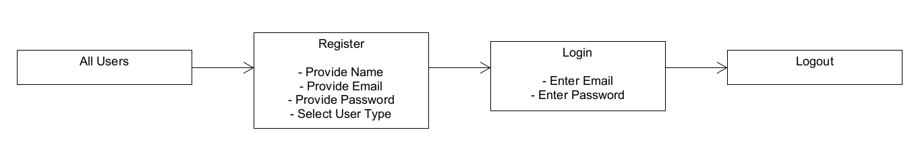
Figure 1.0 User Access Diagram

Inventory Management:
- Description: Retailers can manage their inventory by adding new items, updating quantities, and setting expiration dates for each item.
- Actors: Retailers

Surplus Food Identification:
- Description: Retailers can identify and flag surplus food items that are nearing expiration or are more than demand.
- Actors: Retailers

Listing Surplus Food Items:
- Description: Retailers can list surplus food items on the platform for donation or sale at a discounted price.
- Actors: Retailers

Claim Food:
- Description: Charitable organizations can claim food items listed by retailers available for donation.
- Actors: Charitable Organizations

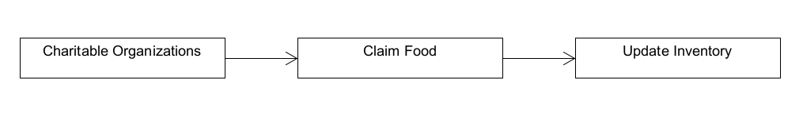
Figure 2.0 Charitable Organization Functional Requirement Diagram

Purchase:
- Description: Consumers can purchase surplus food items listed by retailers at a given discount rate.
- Actors: Consumers

Surplus Food Alert Subscription:
- Description: Users can subscribe to receive surplus food alerts based on their location, communication method (email or phone), and food preferences.
- Actors: All users

Automatic Notifications:
- Description: Users subscribed to alerts receive automatic notifications via email or phone whenever retailers list surplus food items on the platform.
- Actors: All users

Grocery Cart System Example

This diagram shows the interactions between a customer and grocery cart system. This includes adding and removing items from the cart, viewing the cart, and proceeding to checkout.
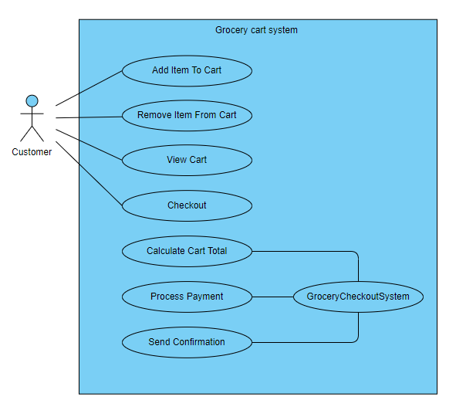
Figure 3.0 - Grocery Cart System Diagram

User Screen Experience
Shows the various screens a user interacts with. This includes the sign-up, login, main screen, checkout, view cart, account information and change password screens.
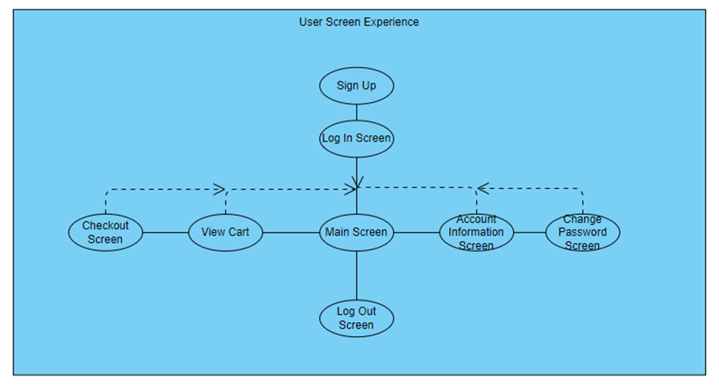
Figure 4.0 - User Screen Experience Diagram

Retailer Screen Experience

Shows the screen experience of charitable organizations. This includes sign-up, login, main screen, create new item, update item, account information, and change password screens.

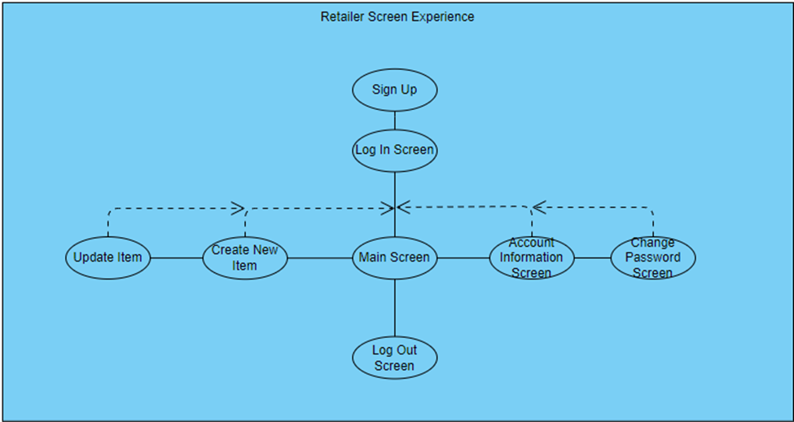
Figure 5.0 - Retailer Screen Experience Diagram

7. Detailed Design

Class Diagrams:
Class diagrams depicting the structure of classes and their relationships
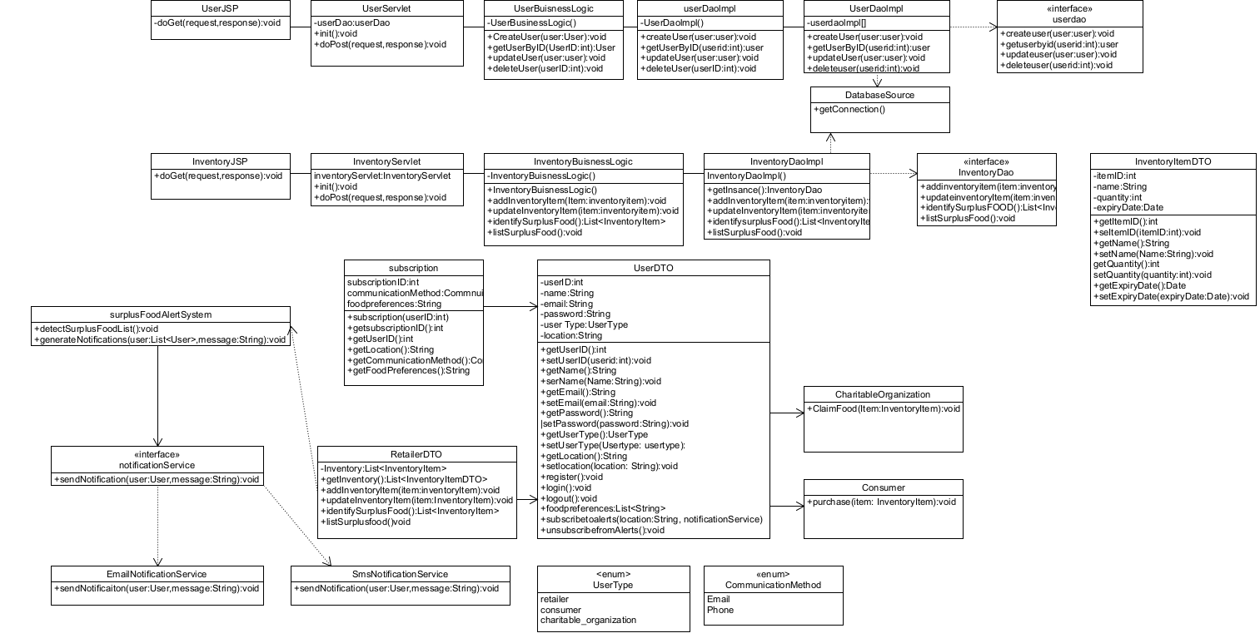
Figure 6.0 - Detailed Class Hierarchy Diagram

Component Diagrams
Diagrams showing the organization and interactions of components.

8. Data Architecture

Entity-Relationship Diagram (ERD):
ERD illustrates the relationships between database entities, including Users, Inventory, Purchases, etc.
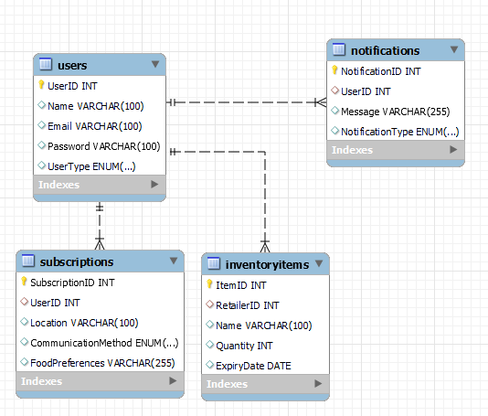
Figure 7.0 - Entity Relationship Diagram Example

Database Model
Schema design and structure, including tables and relationships.

9. Security Architecture

Authentication and Authorization

Authentication: Users must authenticate themselves before accessing the platform. This involves verifying their identity using credentials such as username and password.

Authorization: Once authenticated, users are authorized to access specific features and functionalities based on their user roles (Retailer, Consumer, Charitable Organization). Role-based access control (RBAC) is implemented to restrict unauthorized access to sensitive data and operations.

Data Encryption: Sensitive data such as user passwords and personal information should be stored in encrypted format to prevent unauthorized access. Using Java's PasswordEncoder interface to securely hash and store passwords.

Secure Communication: All communication between clients (web browsers) and the platform server should be encrypted using HTTPS/TLS protocols. This ensures that data exchanged between the client and server remains confidential and secure.

10. Deployment Architecture

Client Devices: Client devices represent the endpoints where users interact with the food waste reduction platform. These devices can include web browsers on desktop computers, laptops, tablets, and mobile phones. Users access the platform's functionalities through a user-friendly web interface or mobile application.

Web Server: The web server hosts the application logic and serves web pages to client devices via HTTP or HTTPS protocols. It handles incoming requests from clients, processes them, and generates appropriate responses. The web server is responsible for managing user sessions, authentication, authorization, and routing requests to the appropriate components of the system (JSP).

Application Server: Manages core business logic and processes data (Servlets).
Database Server: Stores and manages persistent data used by the platform (MySQL, JDBC).
Integration with External Services: Integrates with third-party services to enhance functionality (APIs).
Monitoring and Logging: Tools are deployed to monitor system health, performance, and security (Java).

11. Testing Model

JUnit Testing: Implementation of JUnit tests for code validation, ensuring the correctness of business logic and data manipulation.
Integration Testing: Strategies for testing the integration of components and database interactions, ensuring the overall functionality of the system.

12. References

https://youtube.com/@geekific?si=gkFq-l7mj21BxmqA
https://docs.oracle.com/javaee/5/tutorial/doc/bnafe.html
[1] visualParadigm, https://online.visual-paradigm.com/community/share/cst8288-final-project-use-cases-1u1ni5ezwy

13. Acronyms/Abbreviations

FWRP: Food Waste Reduction Platform
JSP: JavaServer Pages
JDBC: Java Database Connectivity
RBAC: Role-Based Access Control
ERD: Entity-Relationship Diagram
TLS: Transport Layer Security
HTTPS: Hypertext Transfer Protocol Secure
API: Application Programming Interface
RBAC: Role-Based Access Control
JUnit: Java Unit Testing Framework

14. List of Figures
Figure 1.0 User Access Diagram
Figure 2.0 Charitable Organization Functional Requirement Diagram
Figure 3.0 - Grocery Cart System Diagram
Figure 4.0 - User Screen Experience Diagram
Figure 5.0 - Retailer Screen Experience Diagram
Figure 6.0 - Detailed Class Hierarchy Diagram
Figure 7.0 - Entity Relationship Diagram Example

